PRE-COURSE PREPARATION
Debriefing About
Breastfeeding

Dee Bell RM. IBCLC.
Specialist Tongue-tie Practitioner

OVERVIEW
Prior to The Infant Feeding Coach Program starting, I would like you to examine your thoughts and feelings around breastfeeding.

Throughout the course you will learn about the amazing properties of human milk and breastfeeding and this may bring up strong feelings for some of you. You will have an opportunity to discuss these within the group, but it is important you feel happy and safe to do so.
Birth and Infant feeding is a very emotive subject, particularly for those that would have liked to have breastfed but didn’t for any reason, including not having had the opportunity to have children. Or, for those that did breastfeed but didn't meet their own feeding goals. In addition to this on occasion parents' stories can be triggering of our own similar experiences, hopes, wishes, and regrets.

For those who have not had children, either by choice or circumstance, there may be sorrow around not experiencing birth or breastfeeding. For those who will not have children, or have not had children yet, it is easy to have a preconceived idea about what we would do if we were in their situation, perhaps presuming things to be easier or harder than they are.
As an Infant Feeding Coach your role is to support parents on their infant feeding journey, enabling them to achieve a more rewarding experience without judgement, or coercion and ‘without superimposing our own experiences on the parent's and not truly hearing their experience’.
You may find this article by The Association of Breastfeedin
g
Mother’s useful to read
.

Please

c
lick her
e

to view an article explaining how bringing ou
r
own experience of feeding into our feeding support can b
e
unhelpful for the client
.

A
r
t
i
c
l
e
:

BELIEFS & ATTITUDES
Whether or not we are able to provide effective support for breastfeeding parents depends partly on our knowledge and skills, and partly on our attitudes.

If we have a negative attitude towards nursing, it can be difficult to support a new parent to do it. Similarly, if our attitude is very positive it can be difficult to understand a mother who does not feel the same way.

We tend to behave according to our attitudes. Our attitudes are the way we feel about things; they come from our beliefs. What we believe depends on the facts as we see them, which we have worked out from our experiences.
A health professional breastfed for a few days before she stopped and switched to formula, due to nipple pain and baby weight loss.
She had learnt all about the benefits of breastfeeding but believes that breastfeeding is difficult for new mothers and bottle feeding is better ‘because you know what they are getting’.
F
o
r

E
x
a
m
p
l
e
:
Experience: Sore cracked nipples after just a few days of breastfeeding, baby lost weight due to ineffective feeding

Perceived fact: That it is difficult to breastfeed safely and comfortably.

Belief: Breastfeeding is painful and doesn’t work

Attitude: Formula feeding is safer than breastfeeding

Behaviour: Offers mothers who are struggling to establish breastfeeding a bottle of formula so that they feel supported.

BREASTFEEDING ATTITUDES TIMELINE

Sometimes we don’t know where a particular attitude has come from. It can be very helpful to trace it back and re-examine it – especially if we now have access to some new ‘facts’. Filling in the timeline below may help you to identify the source of your own attitudes.

Were you breastfed? Did you see other children in your family breastfed? Try and think right back to the first time you saw a baby or dolly fed? What did you see? And what did you think about each incident?

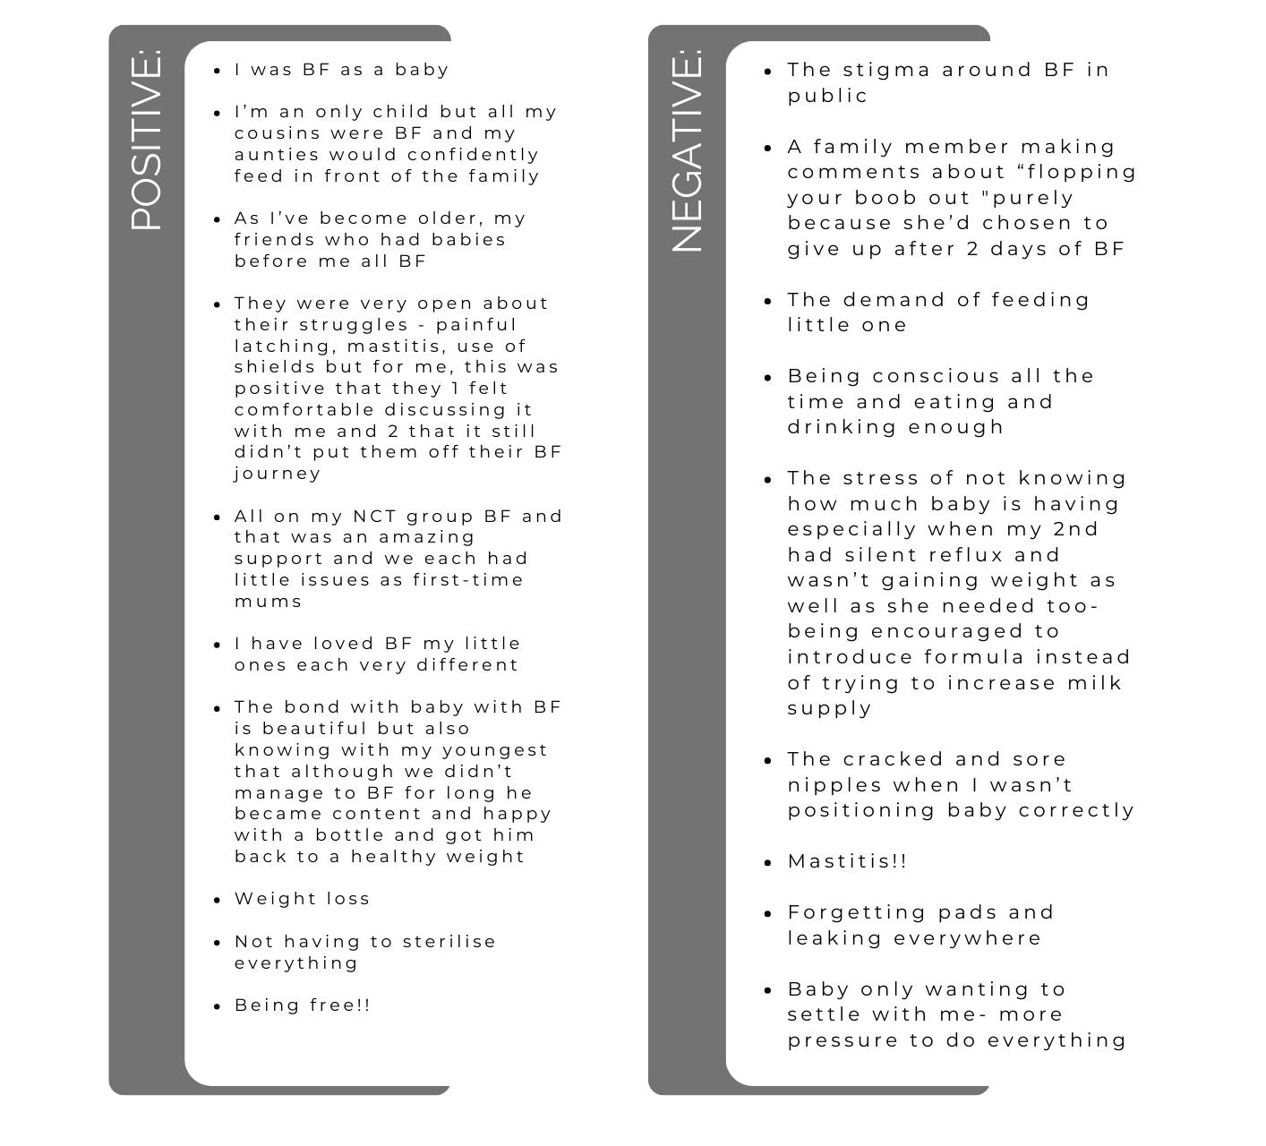
EXAMPLE

BREASTFEEDING ATTITUDES TIMELINE

Use the two columns below to fill in your own timeline, to see where your
breastfeeding beliefs came from. Place all the positive breastfeeding experiences on the left and all the negative ones on the right.

Were you breastfed? Did you see other children in your family breastfed? Try and think right back to the first time you saw a baby or dolly fed? What did you see? And what did you think about each incident?
POSITIVE:
NEGATIVE:

REFLECTION ON BREASTFEEDING
Please note: You do not need to have breastfed to reflect upon your feelings about breastfeeding!
Reflect on your own breastfeeding ‘story’, is it a positive or negative one? If you do not have children; how do you feel about breastfeeding and why?
REFLECTION ON BREASTFEEDING

INFANT FEEDING COACH PROGRAM
What is my intention for this program? (We are going to go in to more detail about your goals for your business later on in the course. So, for now, we are just talking about your intention for this program).
How can I be more focused for the duration of the course?
What will I need to let go of to fully commit to the course?
Where can I ask for more support?

INFANT FEEDING COACH 12 -MONTH PROGRAM
What are the new habits I need to develop in order to get more done in less time?
What do I need to do for me to make my time in this program really impact my practice?
Why is this program important to me?
NAME: DATE:

