MODULE
TWO
Newborn Nurslings

This workbook accompanies module two of the Infant Feeding Coach™ Program

Welcome to Module Two - Newborn Nurslings. This module is all about the newborn period - birth to around the end of the first week.
You will learn how nature intended this period of time to be and how this supports chest/breastfeeding.
For some, this may bring up emotions around your own experience, or lack thereof. I urge you to be subjective and reflect upon how you can support your clients around this period of time and enable them to achieve the best outcomes.
Be kind to yourselves, research and learn, so that you can be the very best Infant Feeding Coach™ you can be.

with love

NEWBORN NURSLINGS

On completion of this module, you will have an in-depth understanding of the need for the mother and baby dyad to be kept together post-birth and how this supports optimal infant feeding and adaption to the outside world.
Building on the foundation of Module One, you will be able to describe which of the UNICEF standards apply to this critical period and be able to teach antenatal clients about the benefits of skin-to-skin for all babies.
You will be able to describe the principles of good attachment at the breast, with an in-depth understanding of how this impacts on milk transfer.
You will have a good understanding of the role of hand expressing post-birth and the need to ensure early and frequent feeds to establish milk supply.
This module is all about gaining a sound understanding of optimal infant feeding and how to facilitate this getting off to a good start.

THE INFANT FEEDING CONTINUUM FRAMEWORK

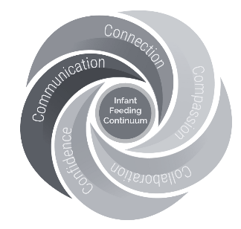

As you work through the online aspects of Module Two, complete The Infant Feeding Continuum Framework below. Note how each of the five 'C’s, relates to these new topics.
Please provide as an expanded and detailed answer as you can. Considering both your relationship with the family, the family's relationship with each other, and your/their relationship with the wider community.

THE INFANT FEEDING CONTINUUM FRAMEWORK
In this section you are being asked to relate the 5cs specifically to the Newborn Nurslings period. Please ensure you include your relationship to the mother as Infant Feeding Coach™, as well as your relationship to the family and the wider supporting network ie, grandparents and other health professionals. Also consider how can the 5cs relate to mother/baby/partner and their relationships to their wider network and other healthcare professionals.

Connection
Compassion

THE INFANT FEEDING CONTINUUM FRAMEWORK

Collaboration
Communication
Confidence

NEWBORN REFLEXES

What do you understand by 'newborn reflexes'?

Please list the nine instinctive newborn behaviours that a healthy unmedicated baby will go through, when placed in uninterrupted skin-to-skin, immediately after birth

1.
2.
3.
4.
5.
6.
7.
8.
9.

NEWBORN REFLEXES
Skin to skin contact regulates ……………………, ………………… and ….………………..
It also calms mother and baby, gives the mother confidence in handling her baby and encourages feeding.
They don’t have to be naked all the time, the baby can be in a nappy and have their bare chest against their mothers with a cover laying loosely over both of them.
When mother and baby are skin-to-skin the hormone of ………………. will flow.
The baby should be skin-to-skin with the nursing parent as much as possible during the first 3 days (and beyond). Research shows that this contact has a large impact on the mothering hormones of ………………….. and ………………….. and the activation of the ………………….. cells (the milk-making cells).
In the first 3 days, the baby should be skin-to-skin with the nursing parent whenever they are awake, as this is vital to encourage feeding and also to calm the baby. If other members of the family want to hold the baby, this is best done when the baby is asleep and will enable the birthing parent to rest.

NEWBORN REFLEXES

How can you ensure a client understands the importance of a peaceful first few days; for themselves, and for their baby to adjust to life outside the womb?

THE VALUE OF SKIN-TO-SKIN CONTACT

Skin-to-skin contact and breastfeeding
Skin-to-skin contact has benefits for both mother and baby.
Name some of the benefits below:
1.
2.
3.
4.
5.
6.

THE VALUE OF SKIN-TO-SKIN CONTACT
Skin-to-skin contact is especially valuable immediately after birth because it helps baby and mother adjust to being separated and to develop their new relationship. Many mothers who did not plan to breastfeed change their minds at this point – this is nature’s trick!
Skin-to-skin contact can also be useful at other times and in other situations. Four examples of such situations, and how skin contact can help, are:
1.
2.
3.
4.

BABIES ARE DESIGNED FOR BREASTFEEDING
What babies know
Healthy, full-term babies can be relied upon to help their mothers to breastfeed them. How would you explain to a mother/nursing parent why it is important for them to let the baby feed whenever they want, for as long as they want?

How babies communicate
Babies give their parents lots of clues that they are ready to feed. Some examples of these feeding cues are:
1.
2.
3.

……………………. is the baby's last resort.

Remember: A baby who is never settled, who always feeds for an hour or more, or a baby who does not release the breast spontaneously at the end of a feed may not be feeding effectively.

KEEPING MOTHERS AND BABIES TOGETHER
Mothers and babies staying in close contact helps chest/breastfeeding to be successful. Please give four reasons for this? Try to use the language you would use to explain this to new parents.
1.
2.
3.
4.

Settling babies
Parents are often tempted to give formula feeds to babies who are unsettled, and this often happens in hospitals in the first few days following birth.
Suggest four ways of settling a fractious baby which does not involve giving food or drinks other than human milk.
1.
2.
3.
4.
HOW BREASTFEEDING WORKS
The baby’s attachment
Attachment is what the baby does to enable them to feed effectively from the breast.
Ineffective attachment means they cannot do this.

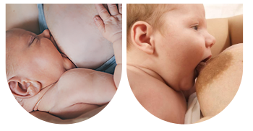

The pictures on the following page shows:
Effective attachment
Figures 1 and 2
Ineffective attachment
Figures 3 and 4
How many differences can you identify between them?
Answers on the next two pages.
HOW MANY DIFFERENCES CAN YOU IDENTIFY?
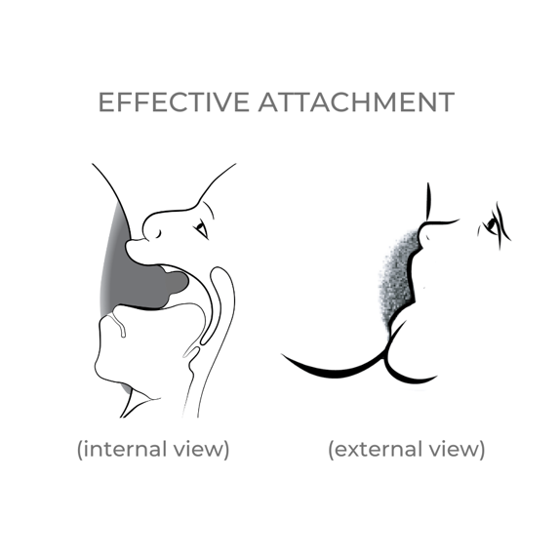
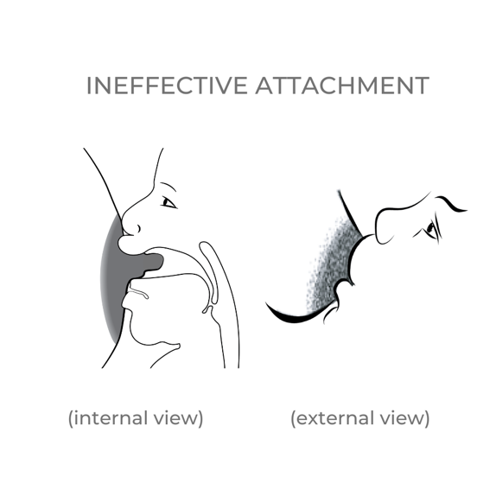

ATTACHMENT IS THE KEY TO EFFECTIVE AND PAIN FREE BREASTFEEDING

The mother can help her baby to attach effectively by:

ATTACHMENT IS THE KEY TO EFFECTIVE AND PAIN FREE BREASTFEEDING
Ineffective attachment can lead to many different problems for both mother and baby.
Three possible consequences of ineffective attachment for the baby are:
1.
2.
3.

Three possible consequences of ineffective attachment for the mother are:
1.
2.
3.

EXPRESSION AND STORAGE OF HUMAN MILK

Give three reasons why a nursing parent might express their breastmilk:
1.
2.
3.

Give two reasons why hand expression may be better than using a pump:

1.
2.

When is the best time to teach a mother to hand express and why?

Describe what an individual can do to make expressing as successful as possible:
PRACTICES WHICH CAN INTERFERE WITH CHEST/BREASTFEEDING
It is very easy to interfere with chest/breastfeeding and cause problems to develop. This interference can come from the nursing parent themselves, or from well-meaning family members, friends or health-care workers.
Stress and lack of support do not in themselves damage chest/breastfeeding, but they can lead a mother to adopt practices which do.
Some examples of practices which can lead to difficulties for the nursing parent and baby are:
1.
2.
3.
4.
5.
6.
7.

CREATING A BIRTH/FEEDING PLAN TO SUPPORT BREASTFEEDING

With reference to the Infant Feeding Preferences Plan (found in the IFA Hub), discuss which aspects you feel are most significant when supporting clients to initiate and establish chest/breastfeeding and why.

NAME: | DATE:

